Sydney T. Lee

Dr. Rahman

CS 305-001

16 November 2023

CS 305 Homework 3 Output and Algorithm Description Document

a. Screenshots of your program output:

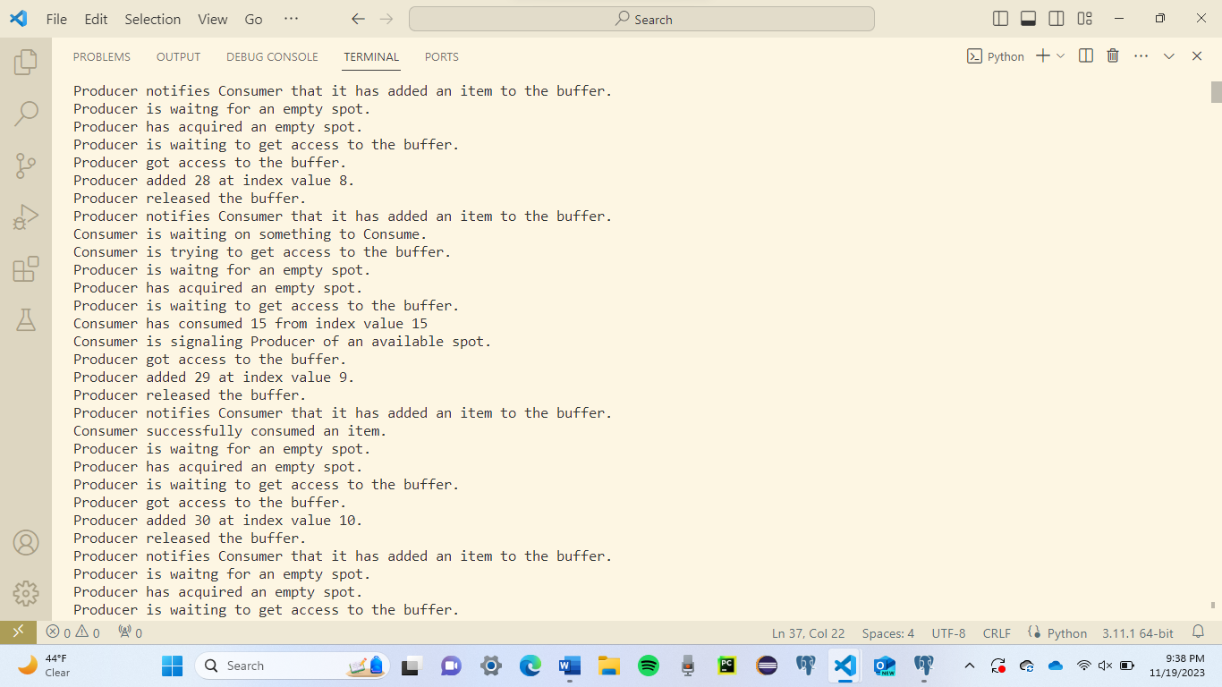

b. a short description of your algorithm design for the producer and consumer thread.

The producer thread is designed to wait for an empty space in the buffer, then acquires that empty space. It waits to gain access to the buffer, and when it gains access, it increments the counter and the index value of the acquired space. Then the producer thread releases the buffer and notifies the consumer thread that it has added something to the buffer, giving the consumer thread something to consume.

The consumer thread is designed to wait for something to consume in the buffer. It waits to gain access to the buffer, and when it gains access, it consumes the item at the index where the producer thread has produced that item. Then the consumer thread signals the producer thread of an empty space to populate and releases the buffer.